My comments as per solution provided

Hi,
I have spent quite reasonable time going through the solution you provided, I have made the comments below keeping in mind that this is a level 300 paper of the final degree program and is worth 30 % of the weightage which means getting low marks in assignment can lead to high chances of failing the paper. But the secret of this assignment is the allocation of marks: The report is 58% marks and Excel sheet for calculations is 42%. The problem with your solution is that you are partially answering these questions not comprehensively and this lead to loss of marks, I can see that you are an expert, so if you take each and every question and address it fully will be helpful. The resources I did upload for you are very helpful especially week 3_10N on building complete portfolio.
I included personal Lecture notes for assignment one which has some key important points. You have written the report as if you are advising someone to build a portfolio based on the data but in this case, you are the one building this portfolio. The key of this assignment is to (1) build optimal risk portfolio and (2) build a complete portfolio from the selected optimal risk portfolio selected and risk-free asset, there is no single information you have provided about the risk-free asset in the report.
Note: Very important, you will need to analyse 5-7 stocks, you select 3 to use to build the portfolio and the other stocks to use for comparison of statistics and analyse competition, this will help you answer questions for the report
Optimal risk portfolio
Two optimal risky portfolios: you have selected three stocks (Stock A, B, C) from the required markets (One stock A from S& P500 and Stock B and C from NASDAQ)
Some examples: https://www.investopedia.com/managing-wealth/achieve-optimal-asset-allocation/
One of the companies you have selected “Alphabet Inc” was created on October 2, 2015 but in this assignment, we are analysing data of a company from “1 June 2012 to 4 June 2019”. The assignment requirement says “When you choose your S&P 500 company, choose one which pays dividends, as he wants some income from his investments. Also make sure all three companies have been listed for a while”. You have mentioned that Alphabet Inc. (GOOG) was formed in 1998. Can you please check on this?
Diversification: You also consider diversification when choosing a portfolio because there is a high risk if you choose stocks from the same industry and if that industry is affected by systematic risk then you lose everything. You have chosen three companies Apple, Microsoft and Alphabet (GOOG) seem to be in the same industry “Technology” but at different stages of production. Can you please check on this?
My comments for the Written Report
- The report should be a follow the formal academic report format using APA reference style with reference list at the end in alphabetical order which will be checked through Plagiarism software. You could have addressed all the key areas of the report part if you could answer questions 1 to 5 in the assignment requirement, I send you under “The written report is worth 58 marks, and it should include the following parts”. THIS IS THE MARKING KEY, I WILL LOOSE MARKS FOR ANYTHING MISSING UNDER THIS HEADING
- The written report is worth 58 marks and the parts to be included are indicated but I have noticed that some parts are missing in some companies, here is the summary
- Information about business life stage of the three companies, industry of some companies and life stage not provided
- Strategies of these firms for developing in the international markets and any business ethical challenges of these firms
- Completely not answered the summary of why you choose the three companies i.e you may have analysed 7 -10 stocks then why choose the three
- Highlighted not answered “Three companies’ basic statistical analysis from your own calculations (return, risk and correlations of your three companies; alpha, beta and R-squared of your companies and whether your companies are overpriced or under-priced; and relevant discussion)
- Very brief summary of the portfolio construction and selection and not worthy 11 marks as per assignment requirement, this section is key as it addresses one of the main objectives of this assignment i.e “building portfolio skills”. Read my comments and suggestions on building portfolio, also refer lecturer notes provided
- Completely not answered i.e 15 marks lost for “Evaluating your three companies by comparing each chosen firm with any two competitors in the same industry using the relative valuation method. You should compare some ratios such as PE, PB, price to cash flow ratio between your chosen firm and its competitors. In addition, you need to consider the market prices of your chosen firm and its competitors.
- Completely not answered i.e 6 marks lost for the future prospects of your three companies based on your analysis and the discussion of the complete portfolio (including any borrowing or lending situation if any).

Note: Please read lecturer notes pdf`s for week 1_10N and week 3_10N for guide on building the two optimal risk portfolios below and your Excel calculations, you can also refer to chapter 6 & 7 from the book (I did upload all these resources you started the assignment.
- Optimal risky portfolio 1: Stock A from S&P500 + Stock B from one of the NASDAQ
After statistical analysis from the calculations (return, risk and correlations of stock A and B companies; alpha, beta and R-squared of your companies, include discussion as to whether companies are overpriced or under-priced; the optimal risk portfolio 1 may look like this
Note this is just an example, need to use actual %

- Optimal risky portfolio 2: Same Stock A from S&P500 + Stock C from one of the NASDAQ
After statistical analysis from the calculations (return, risk and correlations of stock A and B companies; alpha, beta and R-squared of your companies , ,include discussion as to whether companies are overpriced or under-priced: the optimal risk portfolio 2 may look like this : Note this is just an example, need to use actual %

Select the Final optimal risk portfolio either portfolio 1 or 2

- The summary of the portfolio construction and selection (with portfolio weights, return, risk of portfolios and which portfolio is better and why; and any relevant information and analysis)

- Evaluating your three companies by comparing each chosen firm with any two competitors in the same industry using the relative valuation method. You should compare some ratios such as PE, PB, price to cash flow ratio between your chosen firm and its competitors. In addition, you need to consider the market prices of your chosen firm and its competitors.
- The future prospects of your three companies based on your analysis and the discussion of the complete portfolio (including any borrowing or lending situation if any).

Final Complete portfolio
Note: Please read lecturer notes week 3_10N for guide on building the final complete portfolio and your Excel calculations, you can also refer to chapter 6 & 7 from the book:
The calculations from excel plus support notes from week 3_10N should help to discuss the following key point to show how the complete portfolio was build
- How you calculated Y and 1-Y
- Capital Allocation Across Risky and Risk-Free Portfolios, discussion on how P and C were arrived
- Capital Allocation Line: CAL graph can help simply points by relating F and P in order to find C
- Risk Aversion and Allocation
- Answer the utility questionnaire on Pages 174-175 (10th edition) in the textbook and get your “A”--the degree of risk aversion

Now you need to build a complete portfolio using the selected optimal risky portfolio and the risk-free asset
Optimal risk portfolio 1 or 2+ risk free asset=Complete portfolio (C)
Allocate funds between the optimal risky
portfolio and the risk-free asset
- Calculate the fraction of the complete portfolio allocated to portfolio P and to T-bills
- Calculate the share of the complete portfolio invested in each asset and in Tbills
To find complete portfolio you need to calculate the weights that you invest in optimal risk portfolio, that is Y and then once you know the weights and you know the returns and risk of the two assets then you can calculate the return and risk of the complete portfolio, that is the final product
Finally your final portfolio will look like this
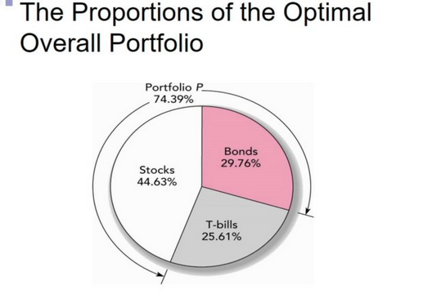

final products are two optimal risky portfolios (Stock A from S&P500 + Stock B from one of the NASDAQ; Stock A from S&P500 + Stock C from one of the NASDAQ ). Then you need to use one of the optimal risky portfolio and risk-free asset to build up your complete portfolio
VERY IMPORTANT THREE STEPS TO FIND COMPLETE PORTFOLIO

Step 1 : Specify the return characteristics of all securities
- Specify the return characteristics of all securities (expected returns, variances, covariances)
- The first thing in your assignment is to construct the following table as it gives you the returns, risk and CC of your securities and to get this table you basically have to use the Air New Zealand example, this table input is step number one

- 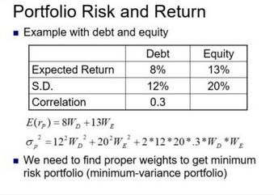

Step 2 : Calculate the properties of P
Establish the risky portfolio
- Determine the weights within the optimal risky portfolio
- Calculate the properties of P using the weights determined in previous step
Once you know the reurns, risk and CC of the securities, now step no 2 is to find P and to find P you need to calculate the weights of the two securies optimal risk portfolio and once you find the weights together with the information in the table in step 1 above then you can calculate the properties (risk and return) of Optimal risk portfolio. So step two is to find optimal risk portfolio
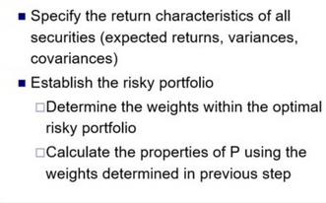

Step 3: Find complete portfolio
Allocate funds between the optimal risky
portfolio and the risk-free asset
- Calculate the fraction of the complete portfolio allocated to portfolio P and to T-bills
- Calculate the share of the complete portfolio invested in each asset and in Tbills
To find complete portfolio you need to calculate the weights that you invest in optimal risk portfolio, that is Y and then once you know the weights and you know the returns and risk of the two assets then you can calculate the return and risk of the complete portfolio, that is the final product
My comments for the Excel Calculations
Step 7 -Can’t see the calculations “Using Jensen’s alpha equation, calculate the alpha of your S&P 500 stock and two NASDAQ stocks3”
Step 8 – Could you please confirm the labels or identification of the calculations whether they are for the S&P 500 Index or S&P 500 selected companies of each optimal risky portfolio; calculating the expected return & risk of the two optimal risky portfolios; and calculating the Sharpe ratios of two optimal risky portfolios. No Discussion of A level provided for step 8
Step 9- Completely not answered
Step 10- Completely not answered
Step 11- Not completed but very important as this assignment test the skills of building a portfolio

